**Smart Health Monitoring System**

**For Elderly People**

**Introduction:**

***Overview:***

**Internet of Things (IOT)** is one of the booming-field in future. Recent improvements in wireless technology have created a new trend in IOT. It plays a major role in the field of health care. Patients with abnormal health conditions can be remotely monitored by smart health care system that uses biomedical sensors to check patient’s condition and uses internet to inform the concerned. This can be encountered through wearable gadgets that continuously monitor the activity and condition of the elderly people. It can also be used at rural areas or villages where nearby clinics or city hospitals can get the data of their patient’s health condition. So, having a smart system, various parameters such as heart beat, temperature, blood pressure etc can be monitored remotely by the concerned, referral doctor and also for personal health care. By using IoT one can monitor the elders regularly and can alert the concerned to react by a message.

***Purpose:***

By this project one can get the present health status of the elderly people from anywhere, at any time remotely. It alerts the concerned people/doctor through a message so that, they can monitor the person health and take care of the person at any time.

**Literature Survey :**

***Existing problem:***

In hospitals, when the patient came to the physician, it may not be possible for the physician to check that patient all the time as the doctor/nurse has to physically move from one person to other for health check. This may be a strain for the doctors who have to take care of a lot number of people in the hospital. If the patient moves to other physician, then he has to start his treatment from the initial point. Many problems were faced by the patients like high amount of money incurred for tests and treatments. Also, when medical emergencies happen to the patient, they are often unconscious. In order to solve these problems faced by the patients as well as physicians, there is a need to develop an environment where these problems can be solved easily and effectively.

***Proposed solution:***

By using IoT, we can develop an application which shows the person health details like Body temperature, Pulse, Blood pressure etc. It is the “Smart Health Care System”. In this, different parameters are measured by sensors in wearable gadgets and these data is sent to the cloud. We can monitor the details through mobile and web apps. If there is any abnormal health status, then the concerned and the referral doctor will be notified through an alert message. This is very useful for the patients and physicians as they can access the information easily at anytime and anywhere.

**Theoretical Analysis:**

***Block diagram:***

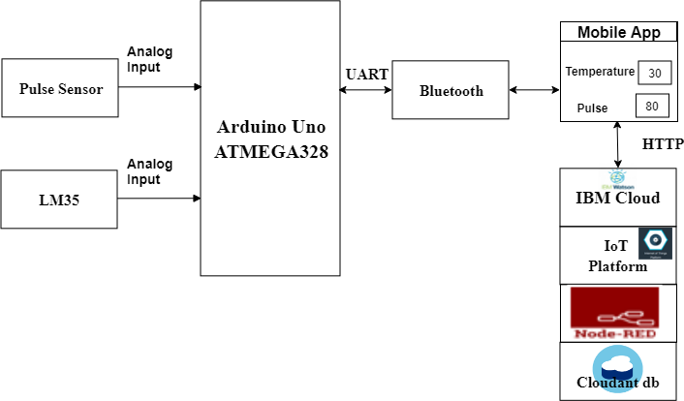

***Hardware / Software designing:***

The hardware and software of this project involve the Arduino Uno ATMEGA328 Model, Pulse and Temperature sensors, IBM Cloud, Bluetooth, MIT App Inventor, Node red and Fast2sms. The two sensors are connected to the Arduino and the values are read by it, processed and then sent to the IBM Cloud services. The data will be displayed in the Mobile application using MIT App Inventor and using Node red the data is displayed in the Web app. Here we use Python language for coding. Fast2sms is used for notification.

**Experimental Investigations:**

The ubiquitous deployment of mobile and sensor devices is creating a new environment called Internet of Things. The performance analysis of IoT applications encounters a lot of challenges such as interaction among a number of different technologies, various usage patterns of smart devices, numerous possible transactions etc. There are several IoT challenges and issues that need to be understood before employing the right solution to a problem that can dynamically vary with the situation. Based on certain critical situations such as IoT health applications, frequent authorization and authentication are necessary and could dynamically vary, resulting in changes to the authorization of IoT devices. To address these issues, automated mutual authentication without human intervention is required.

**Flowchart :**

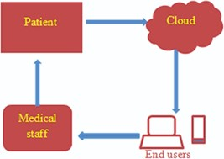

**Result :**

One can see the details of a person from anywhere, at any time and it alerts the concerned people and doctor about that person.

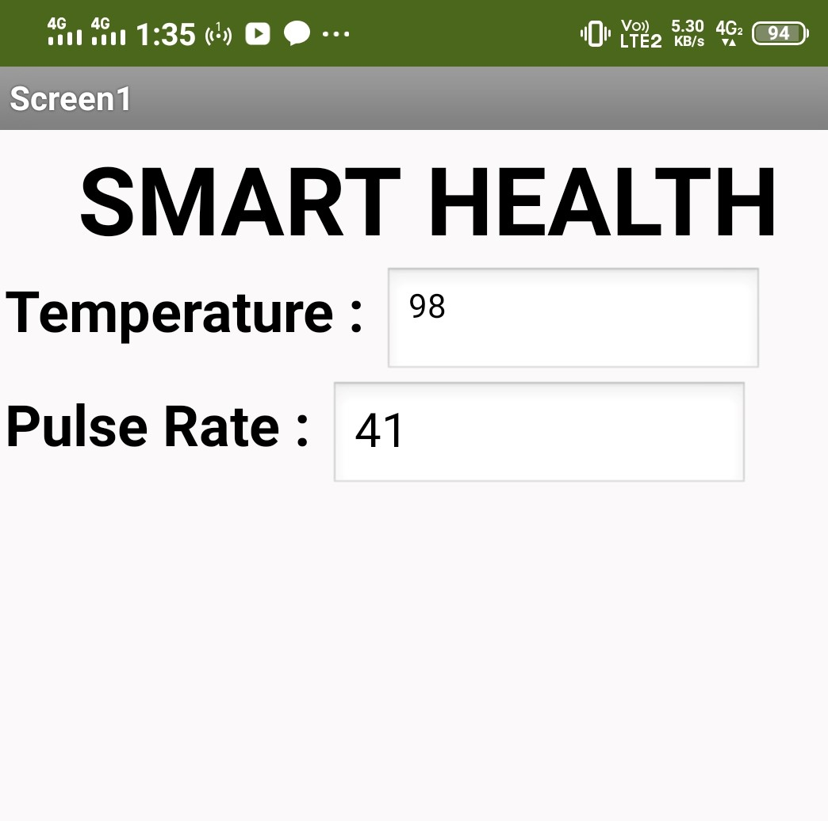

**Advantages & Disadvantages :**

***Advantages of IoT in healthcare:***

* All-around technological enhancement in healthcare.
* Bridging the gap between doctor and patients.
* Can be used in rural areas too.
* Accurate collection of data leads to reduced errors.
* Cost savings for patient by avoiding unnecessary visits by doctors.
* Easy to operate.
* Supports remote monitoring.
* Accessibility to concerned people and doctor from anywhere, at any time.
* Electronic health records of the patient can be maintained.
* Improved Disease Management.
* Notification alerts upon abnormal health of a person

***Disadvantages of IoT in healthcare:***

* The system having the records may get hacked.
* Safety and Privacy may be violated.
* Unauthorized access to centralization.
* Time-consuming in recovery.
* Network issues while uploading data to cloud.
* Risk of failure, due to bugs in hardware or even power failure can impact the performance of sensors.

**Applications :**

* Medication management apps
* Fitness apps
* Glucose level monitoring
* Body, activity, & sleep tracking apps
* Pregnancy monitoring apps
* Individual health recording apps
* Tracked Ingestible Sensors
* Remote Patient Health Monitoring

**Conclusion:**

**Internet of Things** has opened up a world full of possibilities in Medicine. Thus, the proposed system would gather various details regarding health of a patient and the uploaded data in cloud will caution the doctor and concerned individuals about the health condition of that person. It helps in remote monitoring of abnormalities in the body thereby reducing the manual monitoring. It increases the flexibility of the system. It reduces the burden of patients - for visiting a physician and even if consulted a new physician – he can start the treatment by accessing the medical records.

**Future Scope:**

More and more technological advancements in this field increases more applications for different problems and it increases the scope of reduction of problems. The way the healthcare will be administered to people is going to change forever. The digital transformation in health care is inevitable and it seems to be high time to look beyond the challenges and embark on the journey to connected healthcare devices.

**Bibliography:**

1. S. Ananth, P. Sathya and P. Madhan Mohan, "Smart Health Monitoring System through IOT," 2019 International Conference on Communication and Signal Processing (ICCSP), Chennai, India, 2019, pp. 0968-0970, doi: 10.1109/ICCSP.2019.8697921.
2. T. Khan and M. K. Chattopadhyay, "Smart health monitoring system," 2017 International Conference on Information, Communication, Instrumentation and Control (ICICIC), Indore, 2017, pp. 1-6, doi: 10.1109/ICOMICON.2017.8279142.
3. Ebrahim Al Alkeem1, Dina Shehada1, Chan Yeob Yeun1,M. Jamal Zemerly ,Jiankun Hu

“New secure healthcare system using cloud of things”, Springer Science+Business Media New York 2017.